Experiment 1 : P-value of activation patterns being random bernouilli

Cifar 10, 1 layer fully connected layer, 256 hidden units, 1000 draws, 1000 distance per draws.
Histogram of mean distance over 1000 draws of 1000 elements each. Red line is the actual mean of distance distribution over activation patterns.

Epoch 0 : p-value 18 %
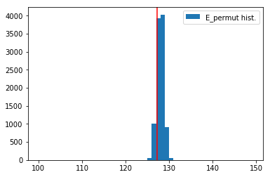

Epoch 5 : p-value 0%
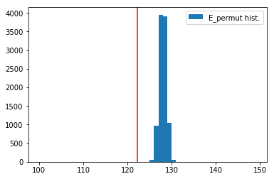

Experiment 2 : Seeking Constellation
In order to seek constellation, we use hierarchical clustering :
Starting from all elements in their own cluster, we build the first cluster based the closest distance hamming between two elements. For an element to join the said cluster, it needs to have a maximum hamming distance between all elements currently in the cluster lower than the distance to all other elements and clusters.

Given this definition we have a tree of clusters with each leaf representing an element, and each node having the value of the maximum distance between all elements below it. We cut this tree with a given distance - for instance 100, and count the number of clusters present beside it.
If the distance is very low : for instance 1, there is a number of clusters equal to the number of elements. If the distance is very large, all elements belong to the same cluster.

It gives us a metric of constellation creation within or neural network : If there is creation of constellations, we should see that for a low distance there is already few clusters : It means that clusters of close elements are created. We compare the formation of clusters with random bernouilli vectors.

Cifar 10, 1 hidden layer - 256 hidden units

Epoch 0 : 10 % accuracy

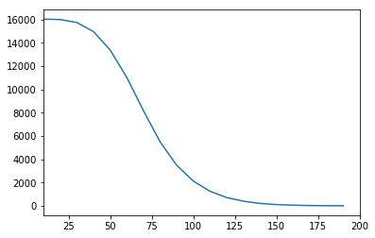

Epoch 6 : 51 % accuracy
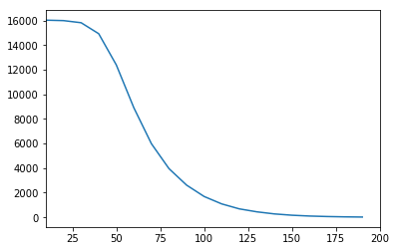

Random Bernouilli vector : 10 draws, 256 hidden units, 16000 elems
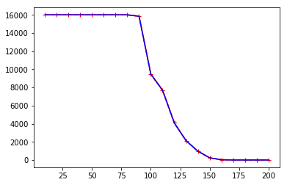

Side experiment : Assessing the usefulness of hidden layers.

Cifar 10, one hidden layer with 256 hidden units
Following the idea of merging classifiers for elements that are close - coarsing the graph.
Let’s create after the first hidden layer a linear layer with each element in the matrix between 0 and 1. And each row summing to one.
Basically it’s a weighted combination of the previous activations. Let’s train a neural network with this new layer. Also in order to force sparsity in this matrix : We want each result component to come from a few previous activations - if we don’t force sparsity we tend to have all activations being used for each output component and it destroys the network accuracy.

Epoch 10 : 54 % accuracy with new layer - 52 % accuracy without new layer.
Let’s look at the sum of the columns : They show how much each activation is propagated forward :

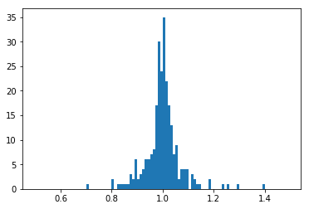

Epoch 10 : nhid 1024 - 51 % accuracy

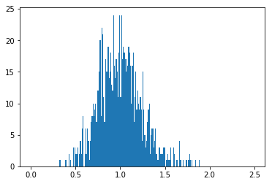
Loss : 1000 * model.attentions[0].abs().mean()

Loss : 4000 * model.attentions[0].abs().mean() - 53-54 % accuracy

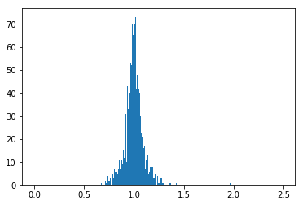

Experiment 4 - Alexnet Probability of activation
3 layer convnet ;
activation_1 = F.relu(self.pool1(self.conv1(x)))
activation_2 = F.relu(self.pool2(self.conv2(self.bn1(activation_1))))
activation_3 = F.relu(self.pool3(self.conv3(self.bn2(activation_2))))
activation_3 = activation_3.view(-1, 64 * 3 * 3)
out = self.fc4(activation_3)

With BatchNorm

Epoch 0 - 10 % accuracy
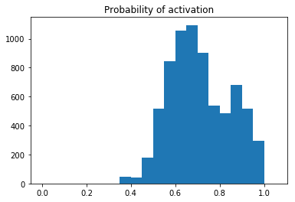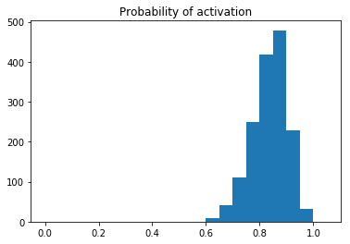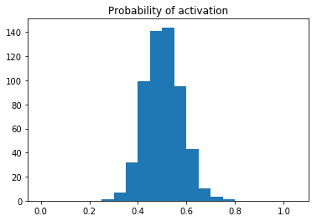

Epoch 14 - 78.38 % accuracy

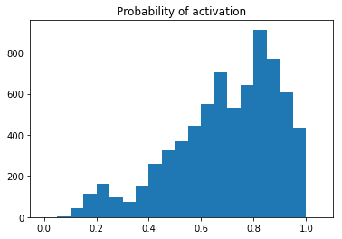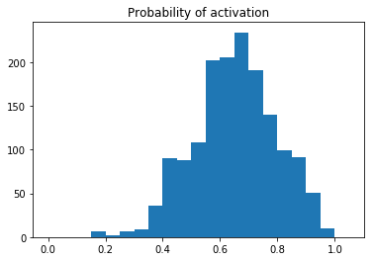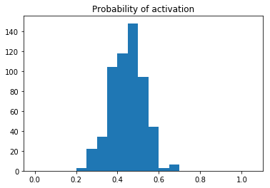

Without BatchNorm

Epoch 0 - 10 % accuracy
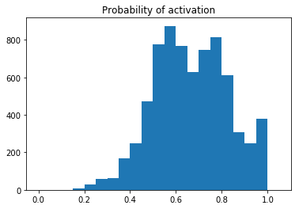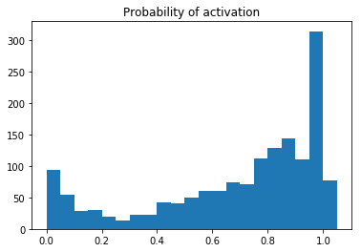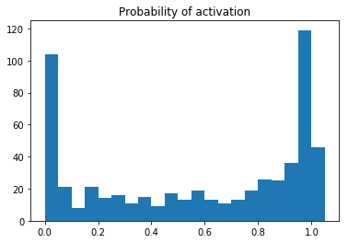

Epoch 16 - 75 % accuracy

